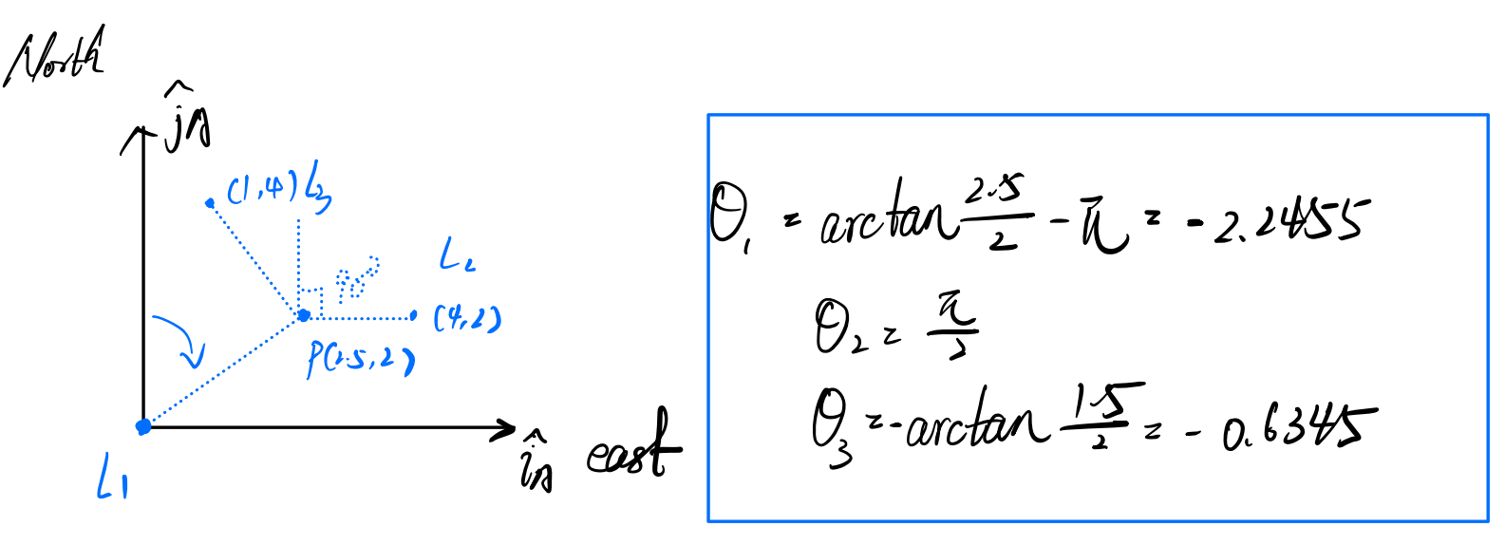

For question1 we use following codes.

clc;

clear all;

theta1 = atan(2.5/2)-pi;

theta2 = pi/2;

theta3 =-atan(1.5/2);

theta_all = [theta1;theta2;theta3];

L1 = [0,0];

L2 = [4,2];

L3 = [1,4];

pos1 = get_pos(theta1,theta2,L1,L2);

pos2 = get_pos(theta2,theta3,L2,L3);

pos3 = get_pos(theta1,theta3,L1,L3);

Px = (pos1(1)+pos2(1)+pos3(1))/3;

Py = (pos1(2)+pos2(2)+pos3(2))/3;

p = [Px,Py];

len_each = 100000;

percentage = zeros(1,10);

dis = zeros(10,len_each);

for j = 1:1:10

sigma = j/10;

inside_times = 0;

for i=1:1:len_each

noised_theta = theta_all+normrnd(0,sigma,[3,1]);

%get 3 potential pos

pos12 = get_pos(noised_theta(1),noised_theta(2),L1,L2);

pos23 = get_pos(noised_theta(2),noised_theta(3),L2,L3);

pos13 = get_pos(noised_theta(1),noised_theta(3),L1,L3);

c_x = (pos12(1)+pos23(1)+pos13(1))/3;

c_y = (pos12(2)+pos23(2)+pos13(2))/3;

c_hat = [c_x,c_y];

S_all = cal_tri_area(pos12,pos23,pos13);

S1 = cal_tri_area(p,pos23,pos13);

S2 = cal_tri_area(pos12,p,pos13);

S3 = cal_tri_area(pos12,pos23,p);

if(abs(S_all-(S1+S2+S3))<10e-6)

inside_times = inside_times+1;

end

dis(j,i) = norm(c_hat-p);

end

percentage(j) = inside_times/len_each;

end

mean_dis = mean(dis,2);

figure(1)

plot(0.1:0.1:1,percentage);

xlabel("sigma");

ylabel("percentage of times");

title("percentage of times that P was inside the triangle versus sigma");

figure(2)

plot(0.1:0.1:1,mean_dis);

xlabel("sigma");

ylabel("average dis from p to chat");

title("average distance of P to chat versus sigma");

The code includes 2 functions “get_pos”, “cal_tri_area”

function pos = get_pos(theta1,theta2,L1,L2)

%from L1 and L2 to get the pos of P

x1 = L1(1);

y1 = L1(2);

x2 = L2(1);

y2 = L2(2);

T1 = tan(pi/2-theta1);

T2 = tan(pi/2-theta2);

M1 = [T1,-1;

T2,-1];

V2 = [T1*x1-y1;

T2*x2-y2];

pos = inv(M1)*V2;

end

function area = cal_tri_area(A1,A2,A3)

x1 = A1(1);

x2 = A2(1);

x3 = A3(1);

y1 = A1(2);

y2 = A2(2);

y3 = A3(2);

area = abs( (x1*(y2-y3)+x2*(y3-y1)+x3*(y1-y2))/2 );

end

And the picture look like below:

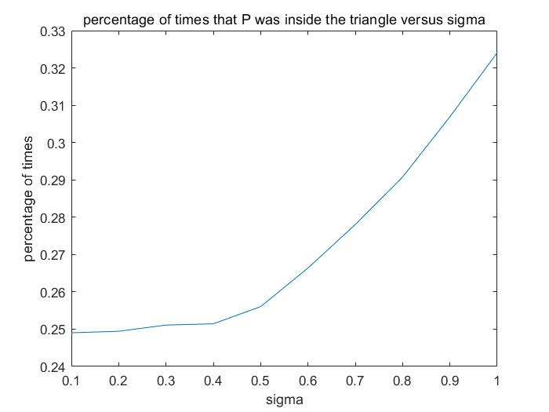

P1: percentage that P was inside the triangle versus sigma

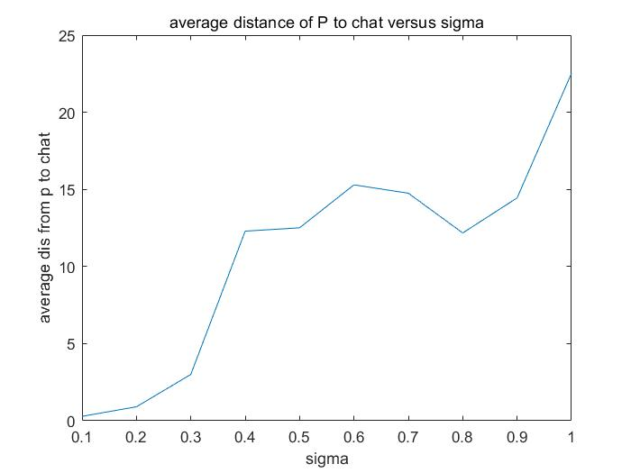

P2: average distance of P to c^ versus sigma

From the picture, we can observe that in general, the average distance from P to c^ is increasing and the percentage of times that P was inside the triangle is increasing with the increase of sigma.

Explanation: sigma represents the deviation from the true angle value. A large deviation means ${\hat{P}}_{\left\{1,2\right\}},{\hat{P}}_{\left\{1,3\right\}},{\hat{P}}_{\left\{2,3\right\}}$ are far from where they should be. Then the triangle formed by these 3 points will become bigger and leads to the increasing possibility that P is inside the triangle. At the same time, as the triangle becomes bigger, the centroid of the triangle will move away from the true position P gradually, and leads to the increasing average distance.

For question2 we use the following code:

clc;

clear all;

load('AE584_Midterm_P2.mat');

L1 = [1.52,0,0]';

L2 = [0,0,0]';

star1 = [0,1,0]';

star2 = [0,0,1]';

P0 = [0.52 0 -1]';

P_all = zeros(3,length(bearingL2St1));

P_all(:,1) = P0;

time = 0:1:length(bearingL2St1);

for i=1:length(bearingL2St1)

theta = subAngL1L2(i);

phi1 = bearingL2St1(i);

phi2 = bearingL2St2(i);

P0 = [0.52 0 -1]';

fun = @(x) two_star_one_angle(L1,L2,x,theta,phi1,star1,phi2,star2);

x0 = P_all(:,i);

options = optimoptions('fminunc','OptimalityTolerance',10e-16);

[x_ans,fval] = fminunc(fun,x0,options);

P_all(:,i+1)=x_ans;

end

figure(1)

subplot(3,1,1)

plot(time,P_all(1,:));

title("position of spacecraft versus time on x-axis");

xlabel("time");

ylabel("position(AU)");

subplot(3,1,2)

plot(time,P_all(2,:));

title("position of spacecraft versus time on y-axis");

xlabel("time");

ylabel("position(AU)");

subplot(3,1,3)

plot(time,P_all(3,:));

title("position of spacecraft versus time on z-axis");

xlabel("time");

ylabel("position(AU)");

figure(2)

hold on

scatter3(P_all(1,:),P_all(2,:),P_all(3,:),'filled');

scatter3(L1(1),L1(2),L1(3),'filled','r');

scatter3(L2(1),L2(2),L2(3),'filled','y');

hold off

title("3D plot of stars and spacecraft trajectory");

legend("spacecraft trajectory","Mar","Sun");

The code includes a function “two_star_one_angle”:

function fun = two_star_one_angle(L1,L2,x,theta,phi1,star1,phi2,star2)

eq1 = dot(x-L1,L2-L1)+norm(x-L1)...

*norm(x-L2)*cos(theta)-norm(x-L1)^2;

eq2 = dot(L2-x,star1)-cos(phi1)*norm(L2-x);

eq3 = dot(L2-x,star2)-cos(phi2)*norm(L2-x);

fun = eq1^2+eq2^2+eq3^2;

if(norm(x-L1)<0.1 || norm(x-L2)<0.1)

fun = fun+10001/(norm(x-L1)*norm(x-L2)+0.01);

end

end

For question2 we use the following code:

And the pictures are shown below:

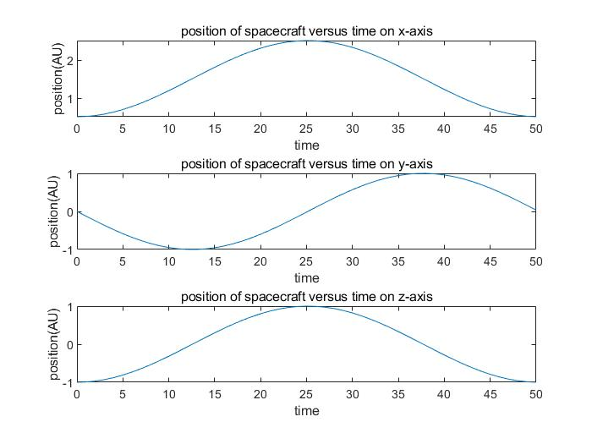

P3: x y z position of the spacecraft versus step K

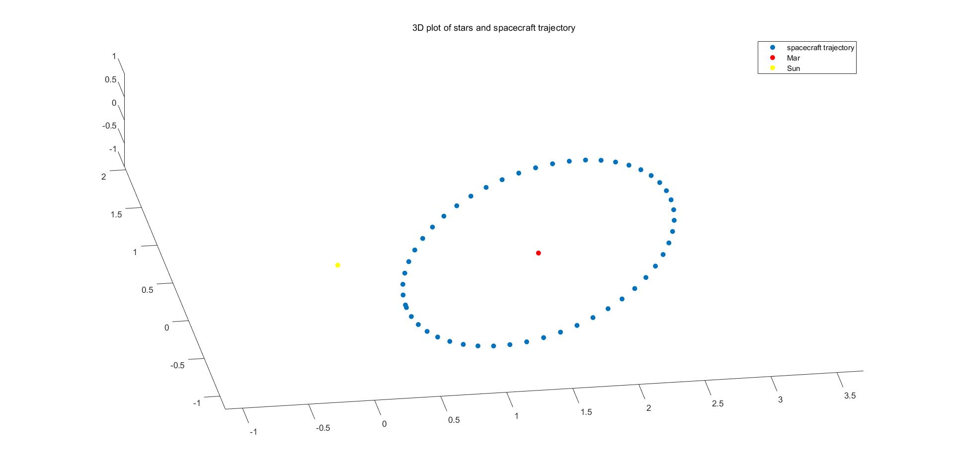

P4: 3D trajectory of the spacecraft in solar system

For question3 we use the following code:

clc;

clear all;

time = 0:0.01:10;

phi_E = 0;

theta_E = pi/6;

psi_E = 0;

%[~,phi_e] = ode45(@(t,phi) sin(0.05*t), time, phi_E);

%[~,theta_e] = ode45(@(t,theta) 0.3*cos(0.01*t), time, theta_E);

%[~,psi_e] = ode45(@(t,psi) 0.5*sin(0.01*t), time, psi_E);

phi_e = 20 * (1-cos(0.05*time));

theta_e= 30*sin(0.01*time) + pi/6;

psi_e = 50*(1-cos(0.01*time));

O_EI = zeros(3,3,length(0:0.01:10));

for i = 1:1:length(0:0.01:10)

O_EI(:,:,i) = zxz_angle2mat(phi_e(i),theta_e(i),psi_e(i));

end

%A = vec_to_mat(w0); % Some arbitrary matrix we will use

F0 = eye(3); % matrix initial value

odefun = @(t,y) deriv(t,y); % Anonymous derivative function with A

tspan = 0:0.01:10;

f0 = reshape(F0,[1,9])';

[T,F] = ode45(odefun,tspan,f0); % Pass in column vector initial value

F = reshape(F.',3,3,[]); % Reshape the output as a sequence of 3x3 matrices

O_BI = F;

O_BE = zeros(3,3,length(0:0.01:10));

for i = 1:1:length(0:0.01:10)

O_BE(:,:,i) = O_BI(:,:,i)*O_EI(:,:,i)';

end

figure(1)

hold on

for i=1:3

for j=1:3

subplot(3,3,3*(i-1)+j);

plot(T,squeeze(O_BE(i,j,:)),'color','#D95319','LineWidth',2);

%plot(T,o_indexs_2(j,:),'b');

txt = [int2str(3*(i-1)+j),'th value of O_{BE}'];

title(txt);

xlabel('time(s)')

end

end

hold off

O1_solutions = zeros(6,length(O_BE(1,1,:)));

for i=1:length(O_BE)

[O1_solutions(1:3,i),O1_solutions(4:6,i)] = cal_Eular(O_BE(:,:,i));

end

T = 0:0.01:10;

figure(2)

subplot(3,1,1);

hold on

plot(T,O1_solutions(1,:),'color','#D95319','LineWidth',2);

title('phi versus time');

xlabel('time(s)');

hold off

subplot(3,1,2);

hold on

plot(T,O1_solutions(2,:),'color','#D95319','LineWidth',2);

title('theta versus time');

xlabel('time(s)')

hold off

subplot(3,1,3);

hold on

plot(T,O1_solutions(3,:),'color','#D95319','LineWidth',2);

title('psi versus time');

xlabel('time(s)')

hold off

function dy = deriv(t,y)

A = vec_to_mat([cos(2*t),cos(2*t),0.025*t]);

F = reshape(y,size(A)); % Reshape input y into matrix

FA = -A*F; % Do the matrix multiply

dy = reshape(FA,[1,9])'; % Reshape output as a column vector

end

The code includes 3 functions “zxz_angle2mat”, “cal_Eular”, “vec_to_mat”

function O_matrix = zxz_angle2mat(phi,theta,psi)

r1 = [cos(phi), sin(phi), 0;

-sin(phi), cos(phi),0;

0, 0, 1];

r2 = [1, 0, 0;

0, cos(theta), sin(theta);

0, -sin(theta), cos(theta)];

r3 = [cos(psi), sin(psi), 0;

-sin(psi), cos(psi),0;

0, 0, 1];

O_matrix = r3*r2*r1;

end

function [solution1, solution2] = cal_Eular(o_matrix)

%get orientation_matrix in, Eular angles out

theta_1 = -asin(o_matrix(1,3));

theta_2 = pi-theta_1;

if(theta_1<0)

theta_2 = -pi-theta_1;

end

Psi_1 = atan2(o_matrix(1,2)/cos(theta_1),...

o_matrix(1,1)/cos(theta_1));

Psi_2 = atan2(o_matrix(1,2)/cos(theta_2),...

o_matrix(1,1)/cos(theta_2));

Phi_1 = atan2(o_matrix(2,3)/cos(theta_1),...

o_matrix(3,3)/cos(theta_1));

Phi_2 = atan2(o_matrix(2,3)/cos(theta_2),...

o_matrix(3,3)/cos(theta_2));

solution1 = [Phi_1,theta_1,Psi_1];

solution2 = [Phi_2,theta_2,Psi_2];

end

function matrix = vec_to_mat(w)

wx = w(1);

wy = w(2);

wz = w(3);

matrix = [0,-wz,wy;wz,0,-wx;-wy,wx,0];

end

And the pictures are shown below:

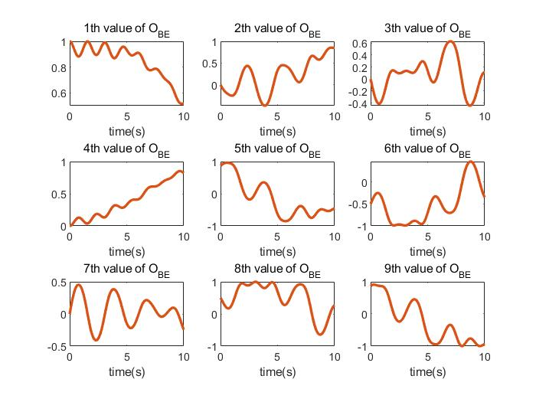

P5: all components of $O_{\left\{B | E\right\}}$ versus time

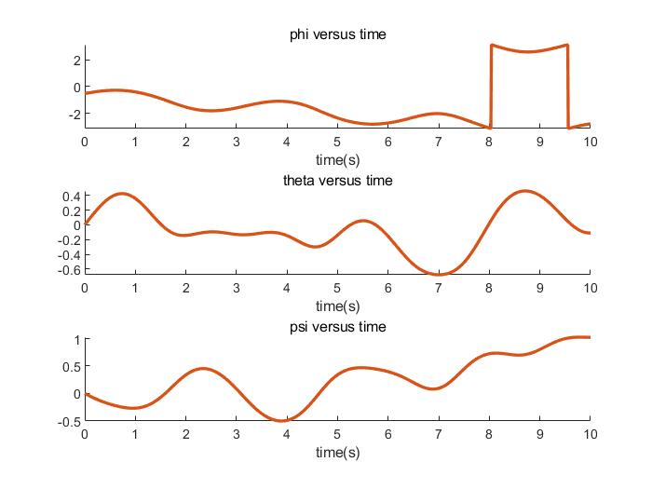

P6: $ϕ, Θ,Ψ$ versus time

For question4 we use the following code:

clc;

clear all;

time = 0:0.01:20;

phi = pi/6;

g = 9.80665;

O_BA0 = [1, 0, 0;

0, cos(phi), sin(phi);

0, -sin(phi), cos(phi)]; % matrix initial value

v_0 = [0;cos(phi);sin(phi)];

r_0 = [1;0;0];

w_BA = [0;0;1];

opts = odeset('RelTol',1e-5,'AbsTol',1e-16);

odefun = @(t,y) deriv(t,y); % Anonymous derivative function with A

tspan = time;

f0 = reshape(O_BA0,[1,9])';

f0 = [f0;r_0;v_0];

[T,F] = ode45(odefun,tspan,f0,opts); % Pass in column vector initial value

%T = F';

O_BA = F(:,1:9);

O_BA = reshape(O_BA.',3,3,[]); % Reshape the output as a sequence of 3x3 matrices

r_cw = F(:,10:12);

figure(1)

hold on

for i=1:3

for j=1:3

subplot(3,3,3*(i-1)+j);

plot(T,squeeze(O_BA(i,j,:)));

%plot(T,o_indexs_2(j,:),'b');

txt = [int2str(3*(i-1)+j),'th value of O_{BA}'];

title(txt);

xlabel('time(s)')

end

end

hold off

figure(2)

hold on

for i=1:3

subplot(3,1,i);

plot(T,r_cw(:,i));

txt = [int2str(i),'th component of r'];

title(txt);

xlabel('time(s)')

end

hold off

figure(3)

plot3(r_cw(:,1),r_cw(:,2),r_cw(:,3));

title("3D trajectory of the center");

grid on;

axis equal;

xlabel("x")

zlabel("z")

ylabel("y")

function dy = deriv(t,y)

w_x = vec_to_mat([0;0;1]);

O_BA = reshape(y(1:9),size(w_x)); % Reshape input y into matrix

O_BA_diff = -w_x*O_BA; % Do the matrix multiply

dy1 = reshape(O_BA_diff,[1,9])'; % Reshape output as a column vector

dr = y(13:15);% same as velocity

g = 9.80665;

phi = pi/6;

a_mean = [-1-g*sin(phi)*sin(t);

-g*sin(phi)*cos(t);

-g*cos(phi)];

dv = O_BA'*a_mean-[0;0;-g]; %acceleration

dy = [dy1;dr;dv];

end

And the pictures are shown below:

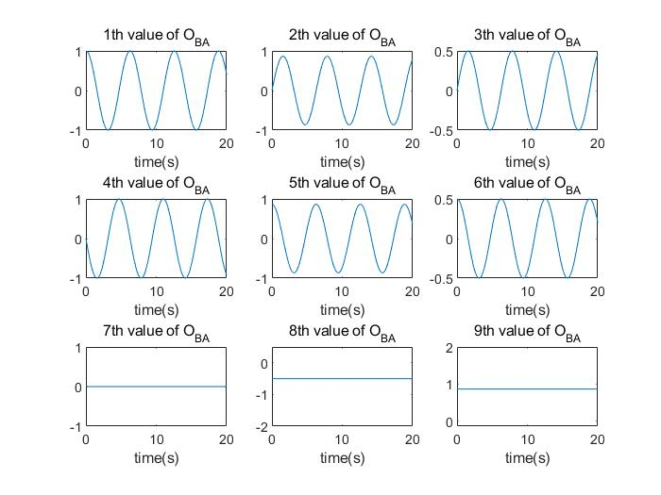

P7: all components of $O_{B/A}$ versus time

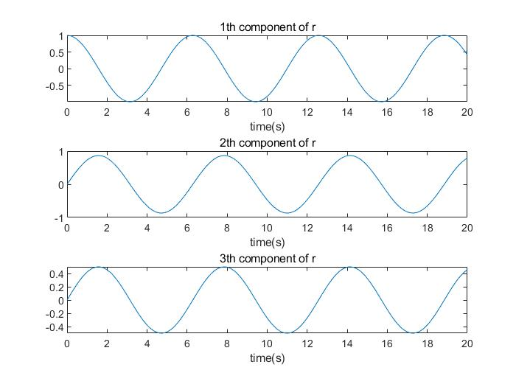

P8: 3 components of $r_{c/w}{\left.​\right|}_{A}$ versus time

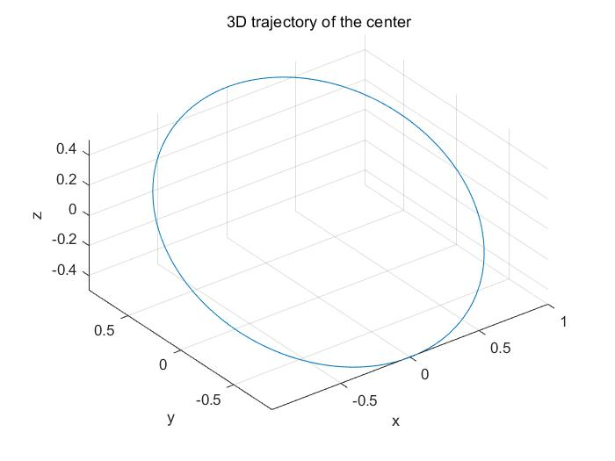

P9: 3D trajectory of the center of mass of the quadcopter